Tablet Phone
last updated by Ujwal 2018-03-29

Galaxy Tab E
* Sussol imel-359760070945403/01 SN-R52H60A9LGW

Galaxy Tab A (2016) White NO 1
* Model number no * SM - T580

Lenovo Tab NO 2
* Lenovo Tab NO 2
* Model- Lenovo TB-x304L
* Android version 7.1.1
* Build number TBx304L-S000030-170517-ROW
* Date 20/08/2021
* Name Nisha Dangol

Lenovo Tab NO 3
- Model- Lenovo TB-x304L
- Android version 7.1.1
- Build number-TB-x304L-S001013-181031-ROW
- Date 20/08/2021
- Name Anil Khatry

Lenovo Tab 4
- Model- Lenovo TB-x304L
- Android version 7.1.1
- Build number-TB-x304L-S000051-180927-ROW

Galaxy Tab E
* Galaxy Tab E * Sussol imel-359514068835377/01 SN-R52H3137CCM
* Date 20/08/2021
* Name Ujwal Khatry

iPad Mini
- Sussol Model-MD528ZP/A SN-DLXKW4TAF193 (2012)
- https://support.apple.com/en-ph/HT201471
- 16GB
- Sussol sell price : Nrs 10,000

Nexus7 5
- Build: number LMY47v
- Model: ME370T

Sussol ipad
* Model-MD510x/A
* SN-DMTJJMU1F182 (2012)
* https://support.apple.com/en-ph/HT201471 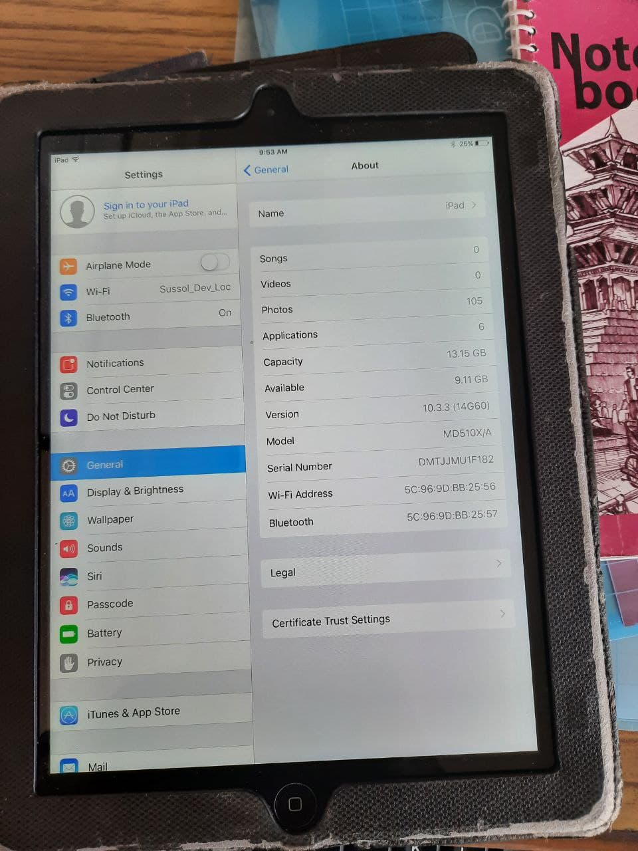

Divice name Sussol (Galaxy Tab E)
* Model Number SM-T561
* Android version 4.4.4
* Build number KTU84P.T561xxu0AQ12
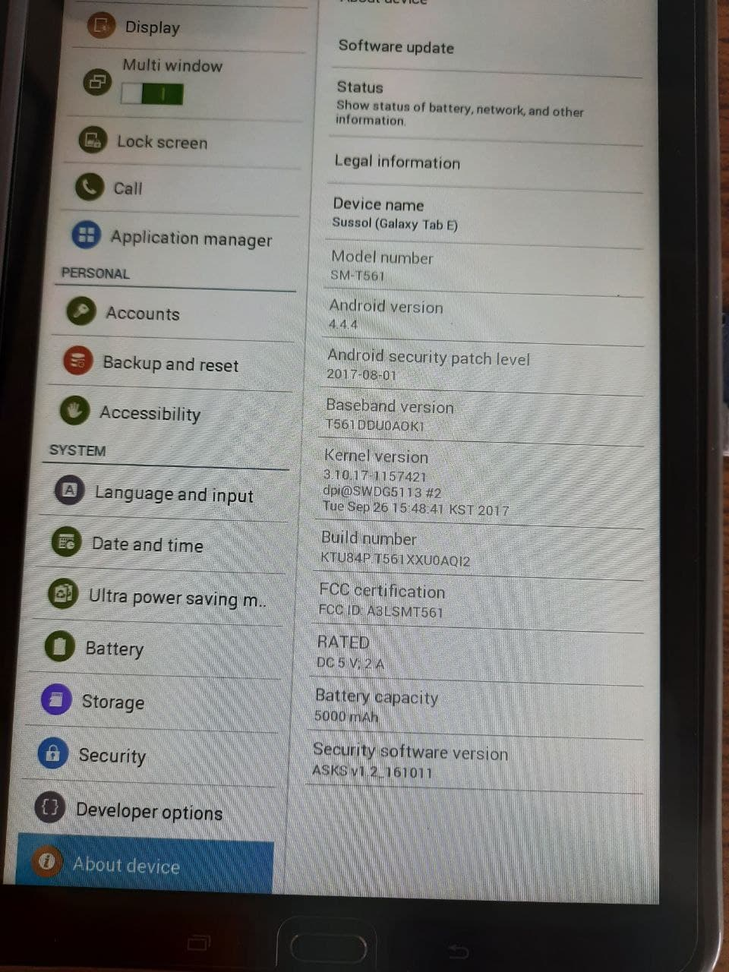

Galaxy Tab A8
* Model Galaxy Tab A8
* Model number SM-X205
* serial number R9PT10JKSWP
* IMEI 351424284682330

