Mikrotik Stup

Hosting Internal server
IP > Firewall > NAT : We can specify our own server for external access.
- 8181 - This is to MAC mini server Time log and mSupply registration page.
- 5900 -- This is to MAC mini screenshare
- 9100 -- This is to the label printer 192.168.3.246 for Moneyworks staff to do some label printing
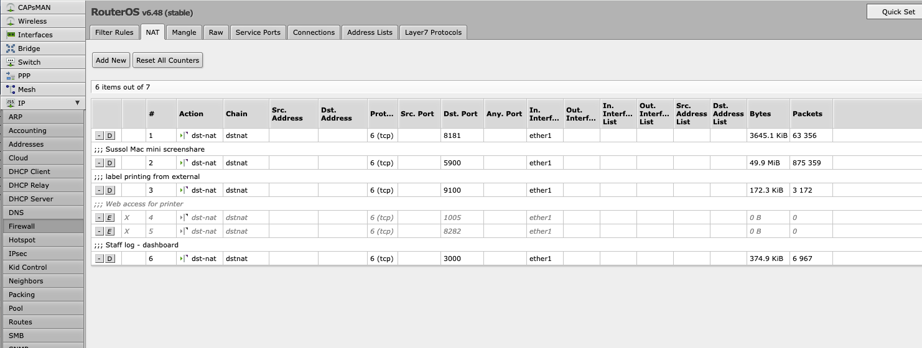
NAT list
Setting for port 8181
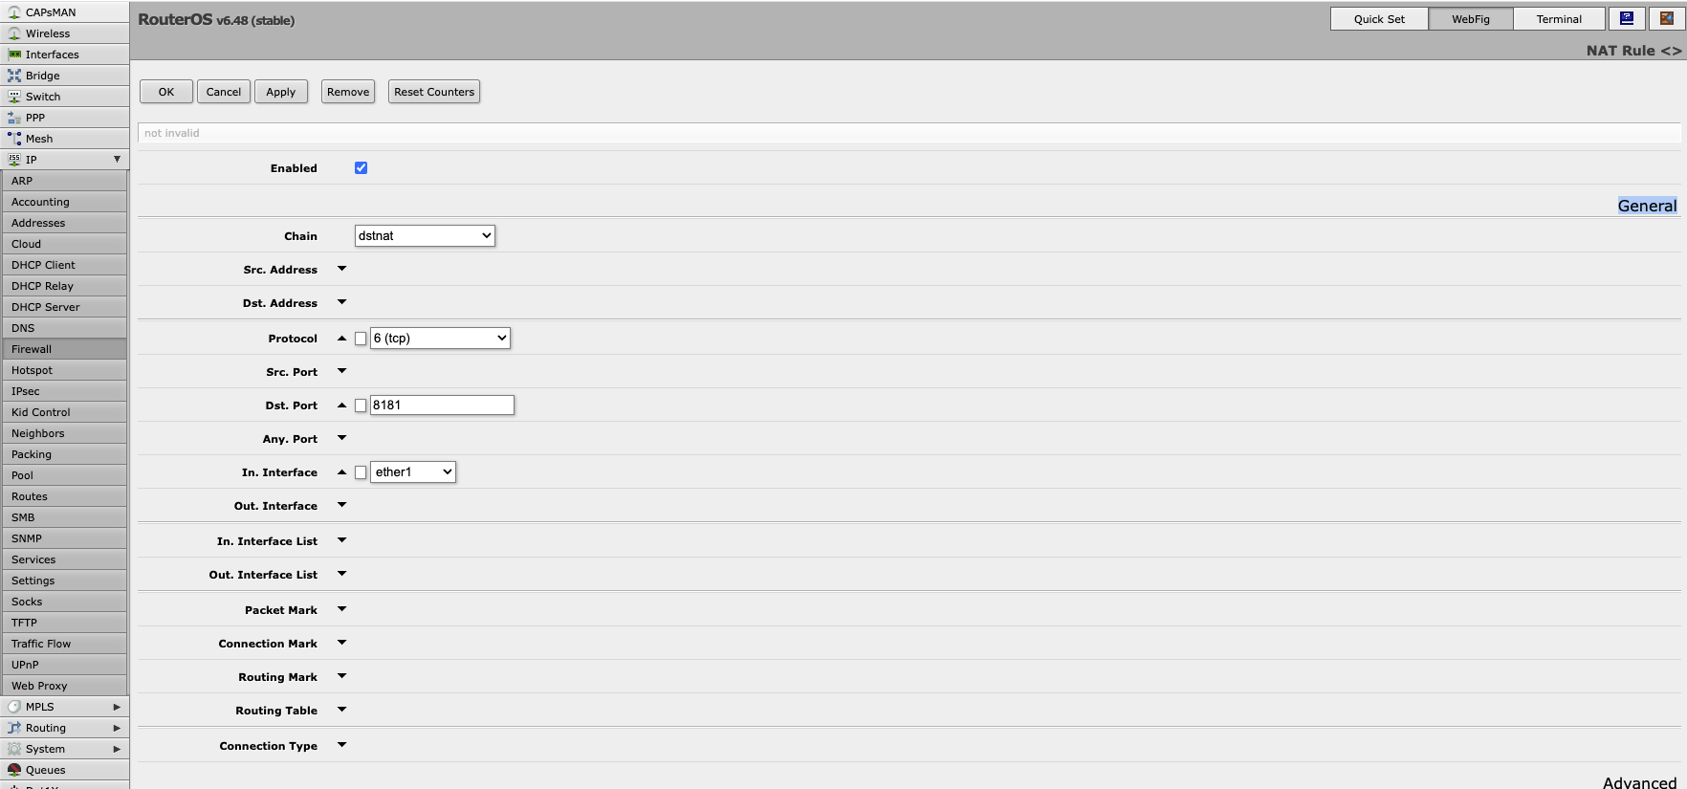
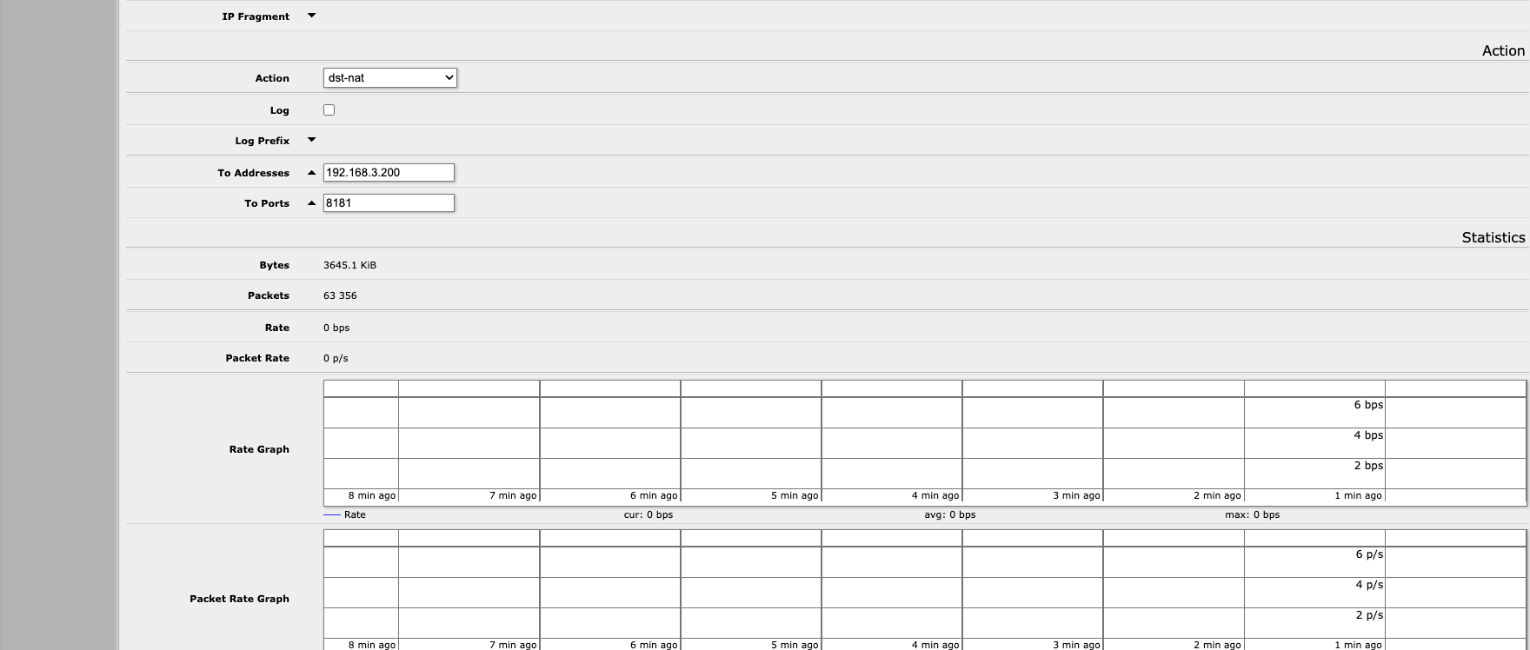

Domain re-direct
IP > DNS > Static button
- We can re-point ktm.msupply.org to our mac mini server : 192.168.3.200

DHCP Server
- IP > DHCP Server > Lease : We can lease IP address to a hardware

