Office for Rent via Kantiphur Tower
I say the sign on my way to the office. Got Dipendra to check it out, we paid a visit.
- Ground floor - parking for car and plenty of motorbike.
- First floor - Premium rent : 900sqft Nrs 1.35lakhs per month ( not for us, it would be for shop or restaurant)
- Second floor (available) or third floor ( taken) : 1200sqft Nrs1.2 lakhs per month ( could be suitable, has a bathroom and kitchen space, but the kitchen fitting is on us ), nrs 100 per/sqft
- The landlord will pay tax they say.
- Fourth floor : The landlord.

Detail
Pros
- Parking : should not be a problem.
- Ample space.
- Landlord work on 5 year contract with increment in-between.
- Close to Busy area but tucked away from it. ( for now as the quiet road now may get busy in two or three years time )
- Landlord to pay tax.
Cons :
- We need to invest and doing the place up. Building the Kitchen, etc… Only the bathroom is handled over as complete. The office will be a bare structure.
- So if we want to place fake celling, it is up to us.

Some Pictures
So we just get the empty bare room, we would need to do the rest :
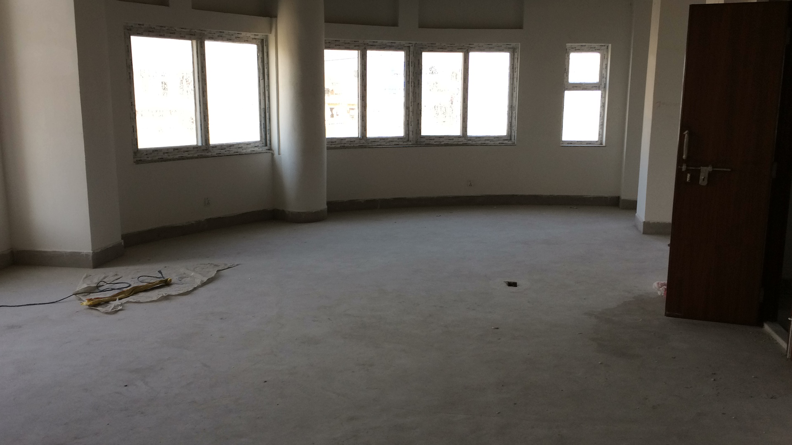
Third floor has been taken up by a IT company with 5 staff…. A bit excessive… i think for the number of staff, unless they plan to expand rapidly…


